

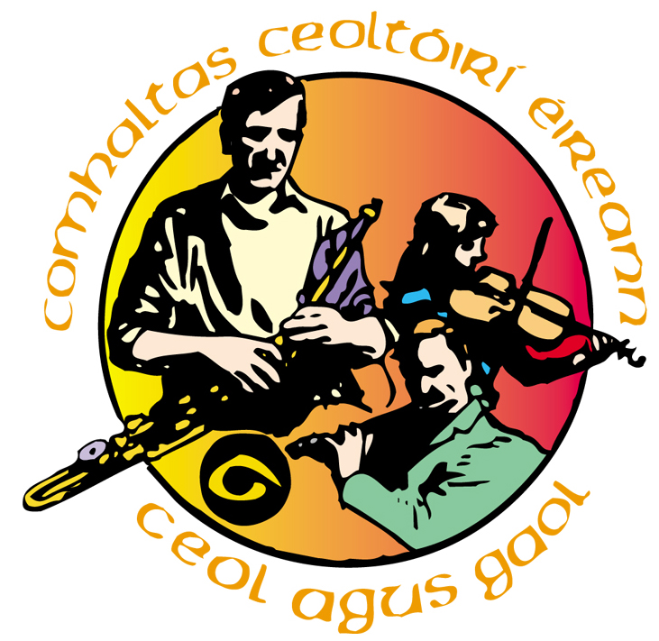
Portglenone CCE
Irish Traditional Music Workshops
14th March 2015
Name:_____________________________________ Contact No:_____________________
Email:______________________________________________ Fee: £5.00 Paid / Not Paid
Contact in an emergency:_____________________________________________________
Address:___________________________________________________________________
Please tick your workshop choice:
Keyboard/Piano Concertina Fiddle Banjo/Mandolin
Accordion Singing Tin Whistle Flute Bodhran/Drums
To determine which workshops will run or not, we require the workshop registration slip to be returned by 10th March 2015. All workshops will run depending on the number of people interested in that workshop.
Signed:_____________________________________________ Date:__________________
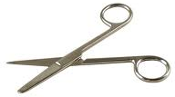
…………………………………………………………………………………………………

Portglenone CCE
Irish Traditional Music Workshops
14th March 2015
Name:_____________________________________ Contact No:_____________________
Email:______________________________________________ Fee: £5.00 Paid / Not Paid
Contact in an emergency:_____________________________________________________
Address:___________________________________________________________________
Please tick your workshop choice:
Keyboard/Piano Concertina Fiddle Banjo/Mandolin
Accordion Singing Tin Whistle Flute Bodhran/Drums
To determine which workshops will run or not, we require the workshop registration slip to be returned by 10th March 2015. All workshops will run depending on the number of people interested in that workshop.
Signed:_____________________________________________ Date:__________________

